* **Backend**
  + **Database**

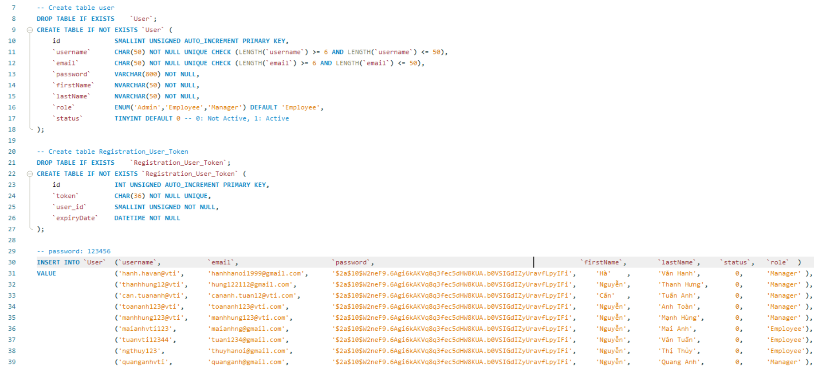

* + **Check exists user & email**

|  |  |
| --- | --- |
|  |  |

* + **Create user**

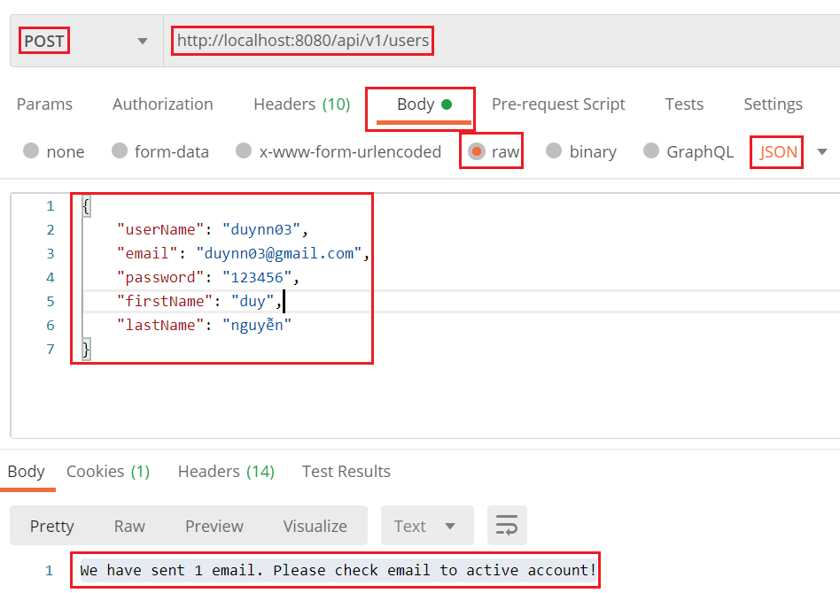

*Api*

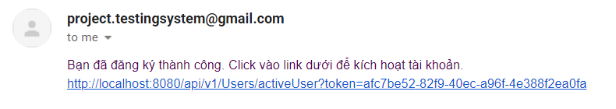

*Gmail*

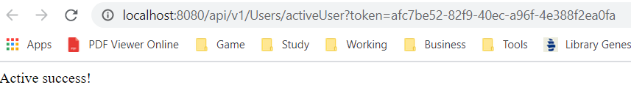

*Active account*

* **Frontend**

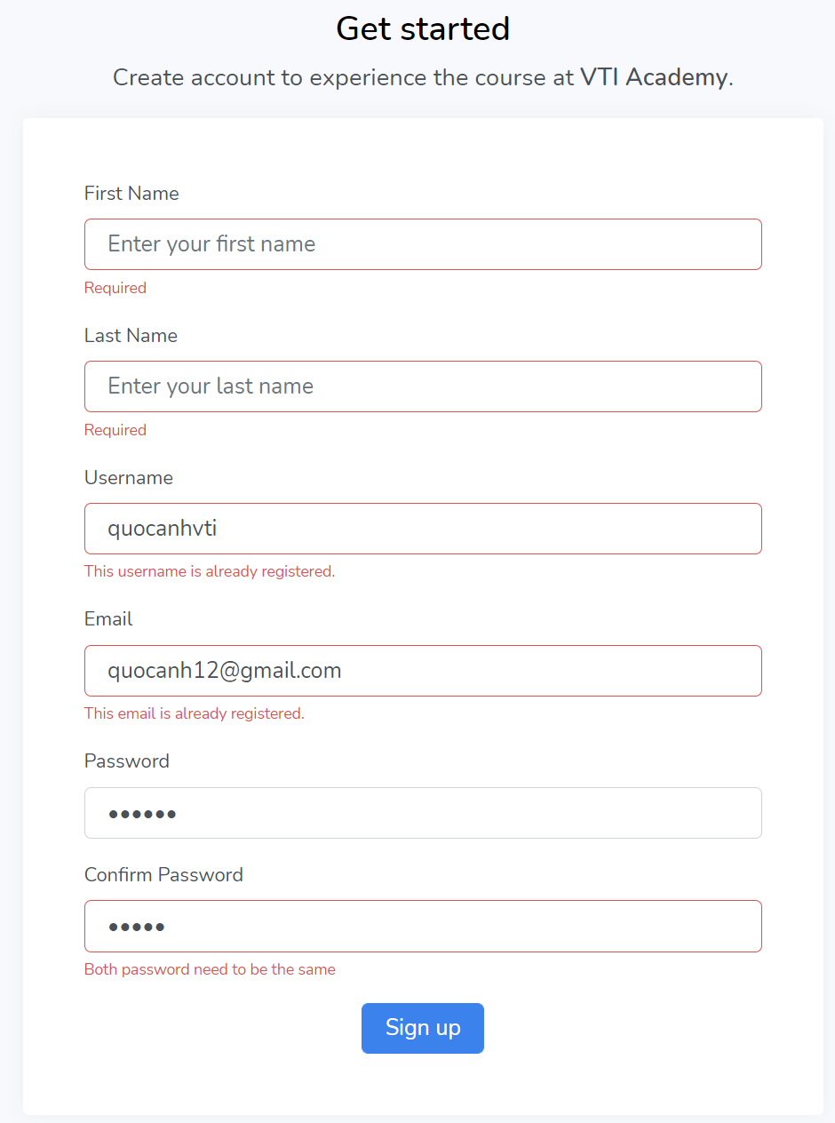

*Sử dụng Formik để validate*

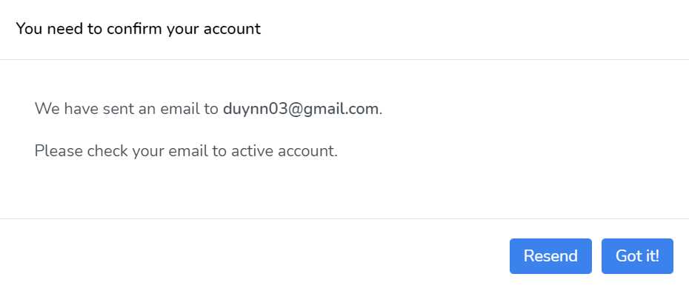

*Sign up successful*

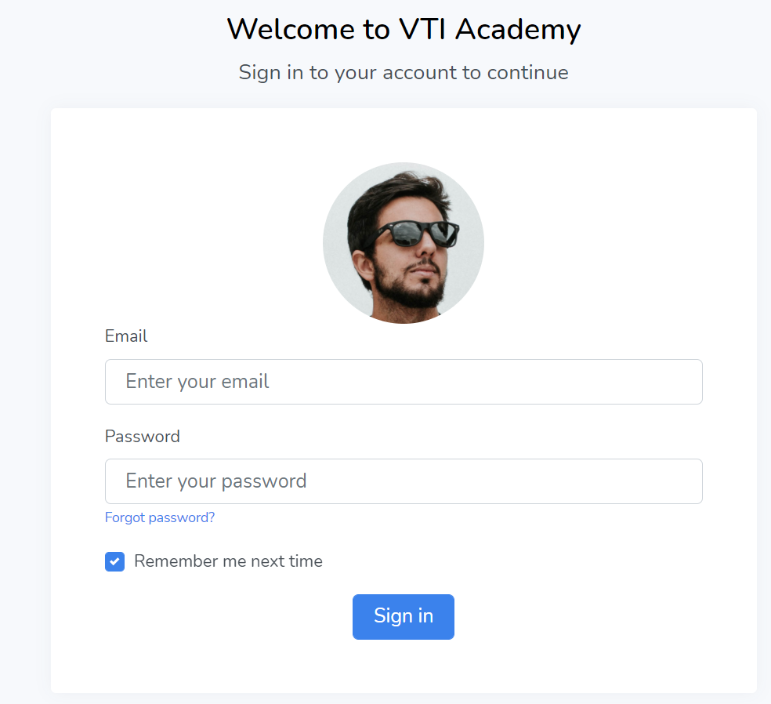

*Login page*

* **Reference**